## Main task

At the end of this homework you need to have:

1. AWS Admin (your user that can manage everything in account);
2. EC2 Admin user that can connect to your EC2 users via SSH and can`t work with RDS;
3. RDS Admin user that can manage RDS, but can`t manage EC2;
4. VPC with 2 subnets and security groups (will provide security group configuration as basic EPAM configuration);
5. 2 EC2 instances: - EC2 instance with your application from Spring homework; - EC2 instance with RDS;
6. RDS should have configured update and backup policy;
7. E-mail notification should be sent to RDS admin and AWS admin on configuration changes.

1. **Create AWS account. Create IAM users:**

* EC2 Admin.
* RDS Admin.

1. **Create VPC** with 2 subnets and set up separate security groups for these subnets and restrict connection types from internet to this VPC:
2. REST
3. DB

**3. Create servers from AMI for**:

1. Web Application(EC2). Install OpenJDK 1.8
2. DB(RDS). PostgreSQL DB.

**4. Setup RDS**

1. Configure update and backup policy.
2. Send email notification to Administrator and DB Admin on Event(exchange configuration)

**5. Deploy application from your Spring to EC2 server and migrate DB to RDS.**

Note: you should create EC2 instance and run your application on it

* Create AWS account. Create IAM users:
* 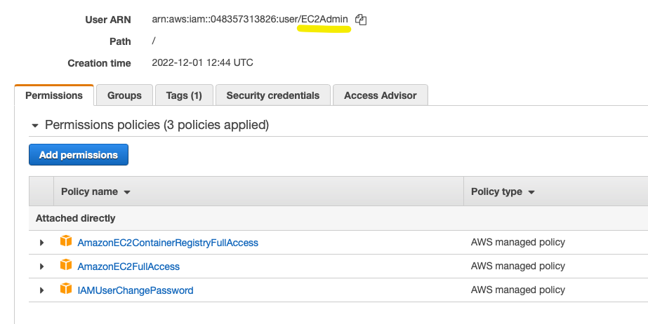
* 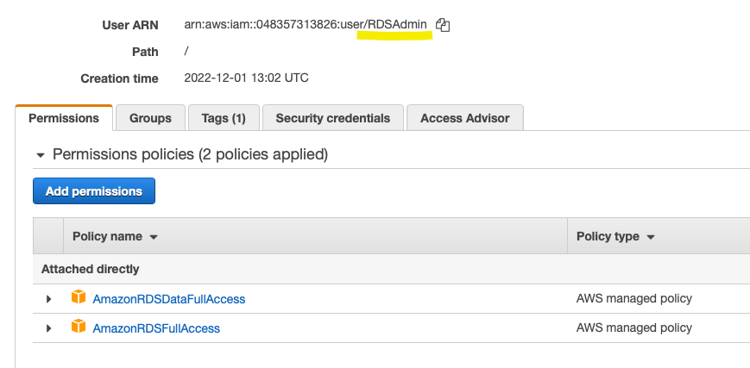
* *Create VPC, use 10.0.0.0/16 Subnet IPv4 CIDR Address Blocks*

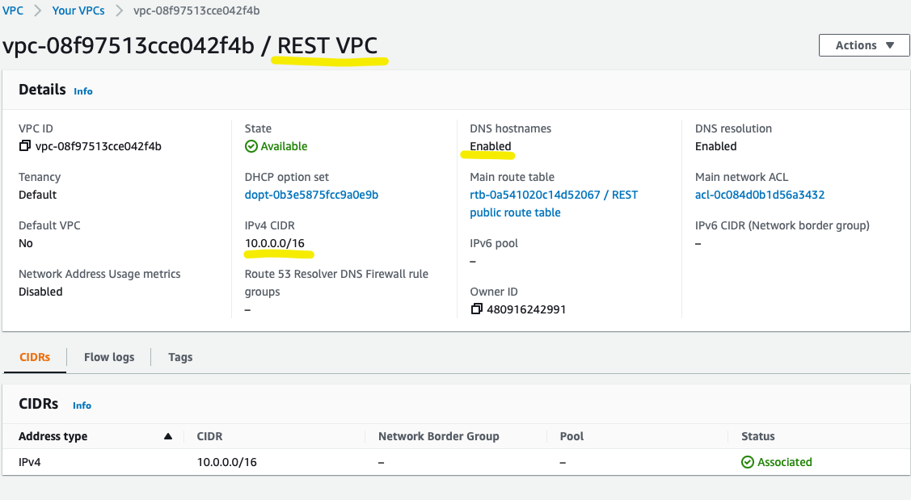

* *Create Internet Gateways and attach it to the VPC*

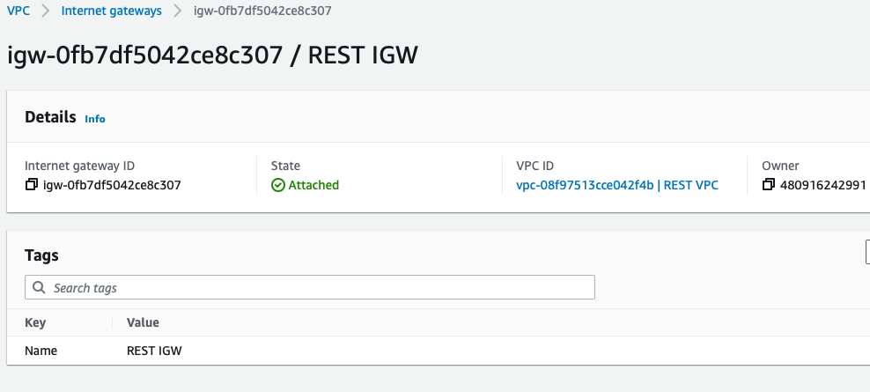

* *To make this subnet available through DNS:*

*select Actions => Edit DNS Hostnames ---> Change DNS hostnames: to YES*

* *Create REST Public Subnet in this VPC,* 
  + *change parameter “auto assign public IP4’ to YES*
  + 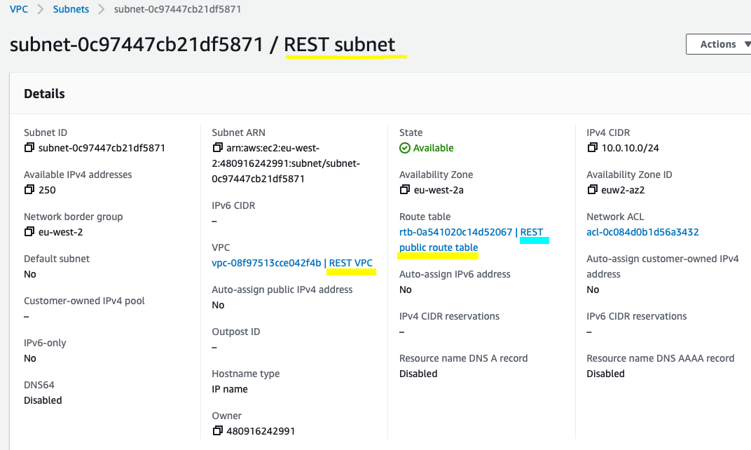
  + *Change its route table. We need to have the internet connection into the public subnet.(add route with destination 0.0.0.0/0 and target Internet gateway which was created before). It is better to add a name for the table.*
  + 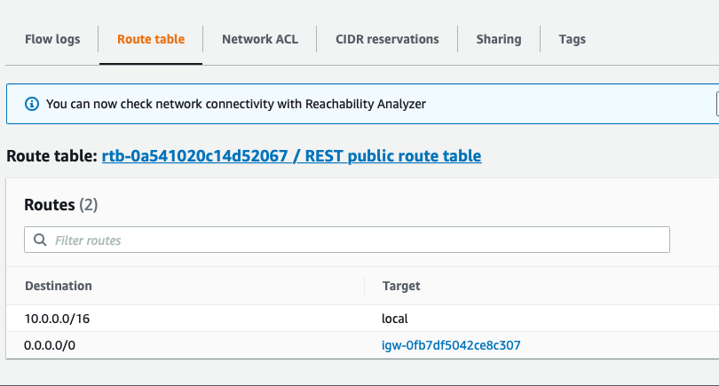
* *Create RDS Private Subnet in this VPC,* 
  + *Parameter “auto assign public IP4” we do not have to change. It must be As default NO.*
  + 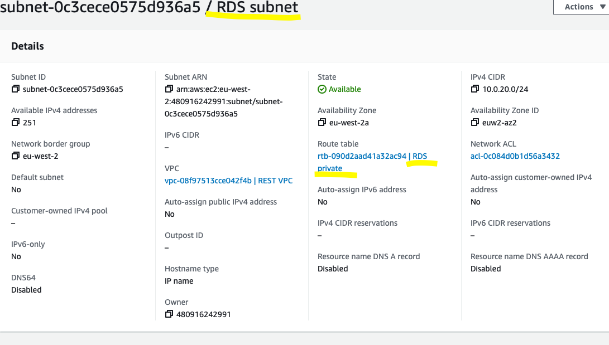
  + *By default subnet has the same route table as previous. Create the new one without entering the internet. It must have only local connection inside the VPC.*
  + *Attach Subnet to the created private route table( only local target)*
  + 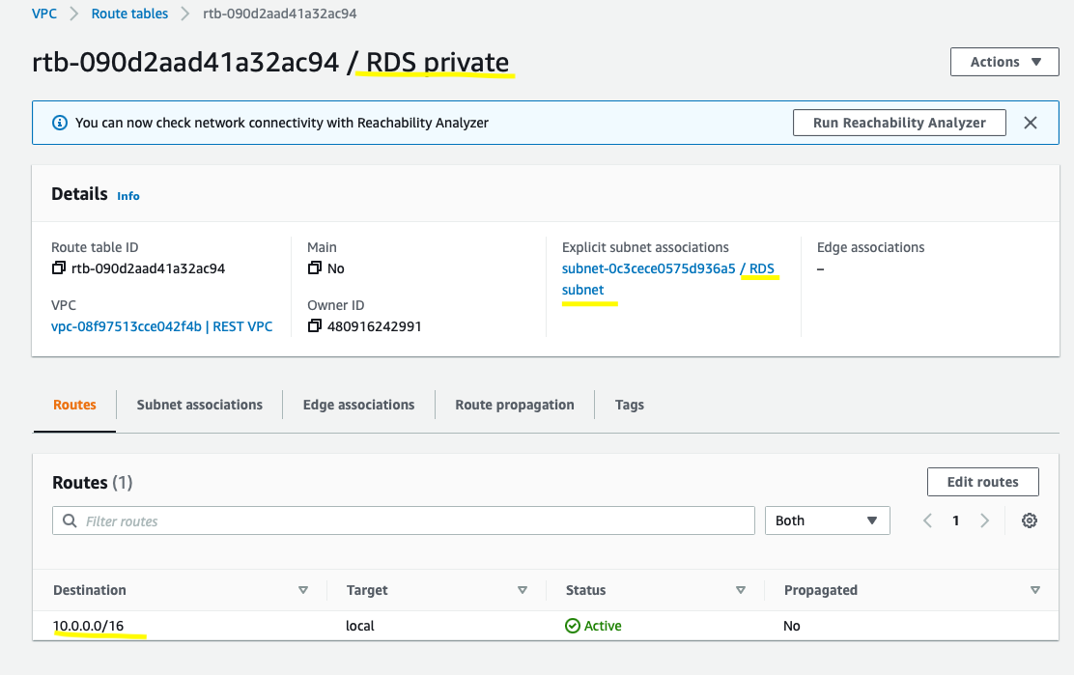
* *Create EC2 instance in the public subnet*
  + *Install java*

sudo amazon-linux-extras install java-openjdk11

* *Create Database RDS*
  + *Create a private subnet group which contains two private subnets in two availability zones - we need to add it in our VPC.*
  + 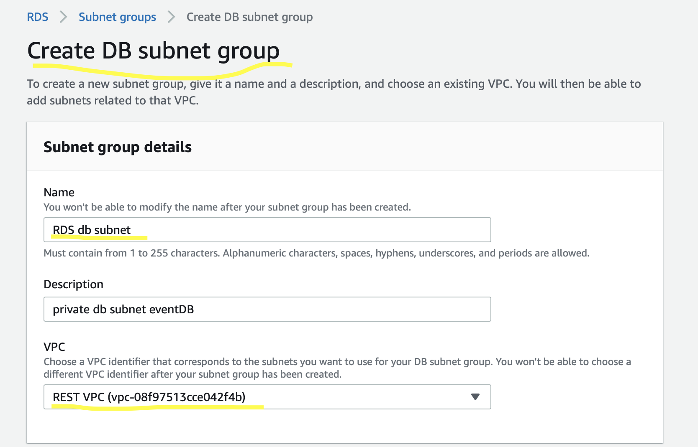
  + 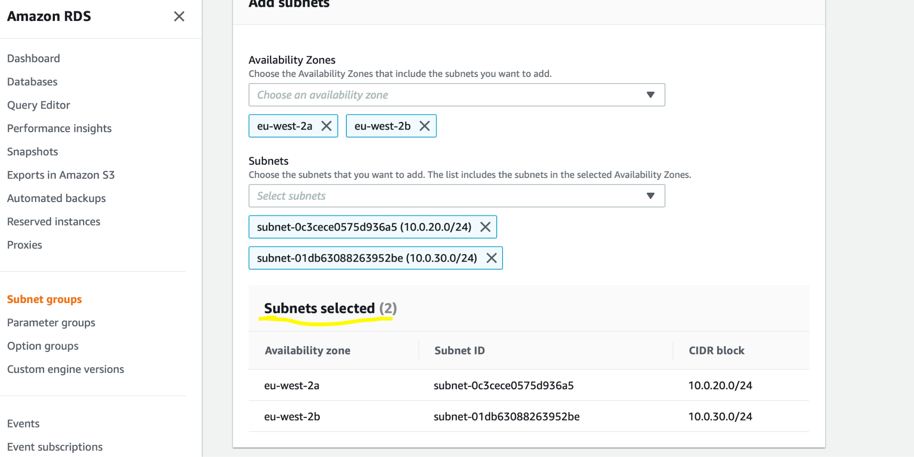
  + *Create DB with free tier*
  + 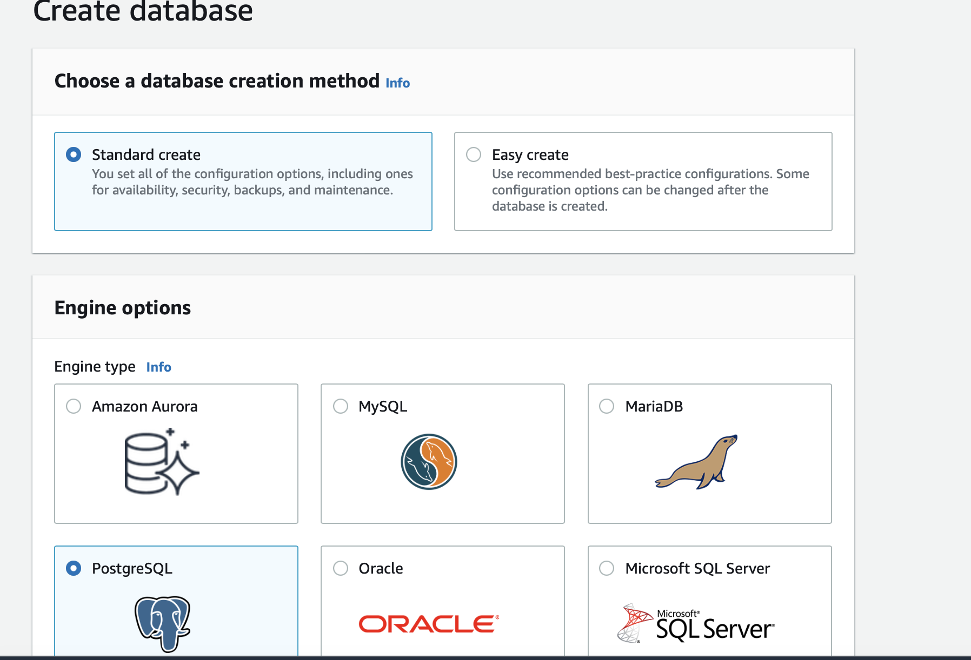
  + *Add instance identifier(these credentials we will use to connect from event App, and we will write them in the properties file)*
  + 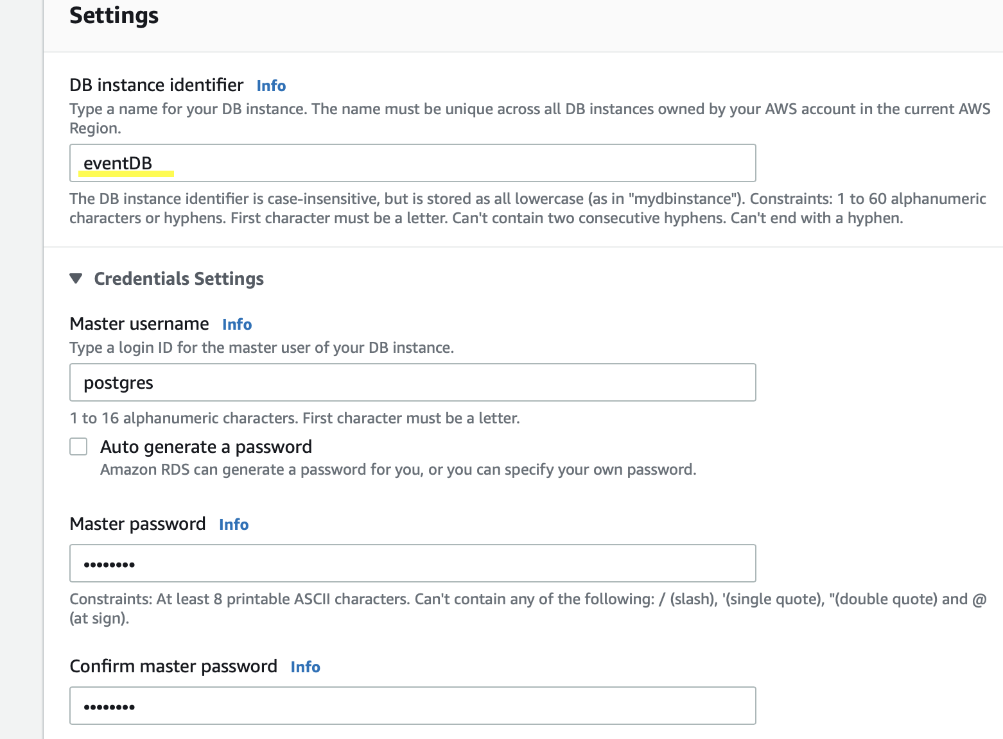
  + *Add backup policy*
  + 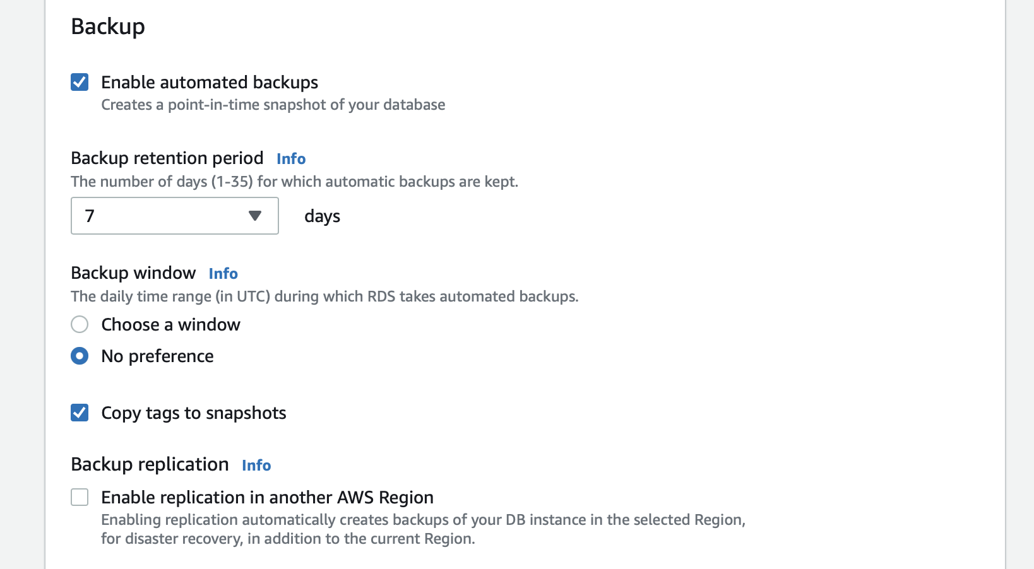
  + 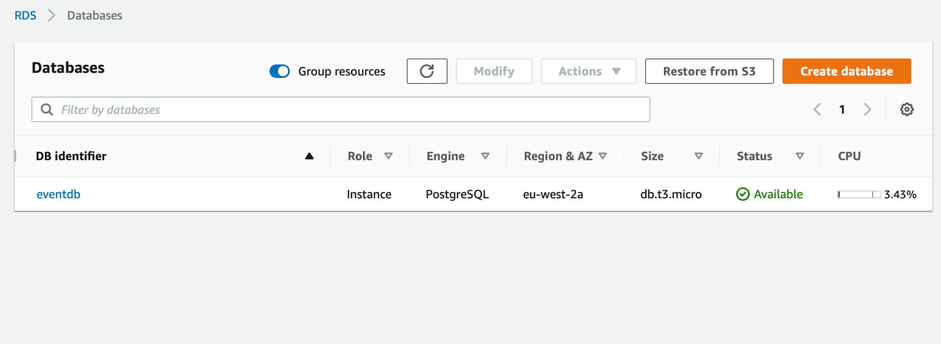
  + *Create connection to your ec2 linux server instance(REST event )*
  + 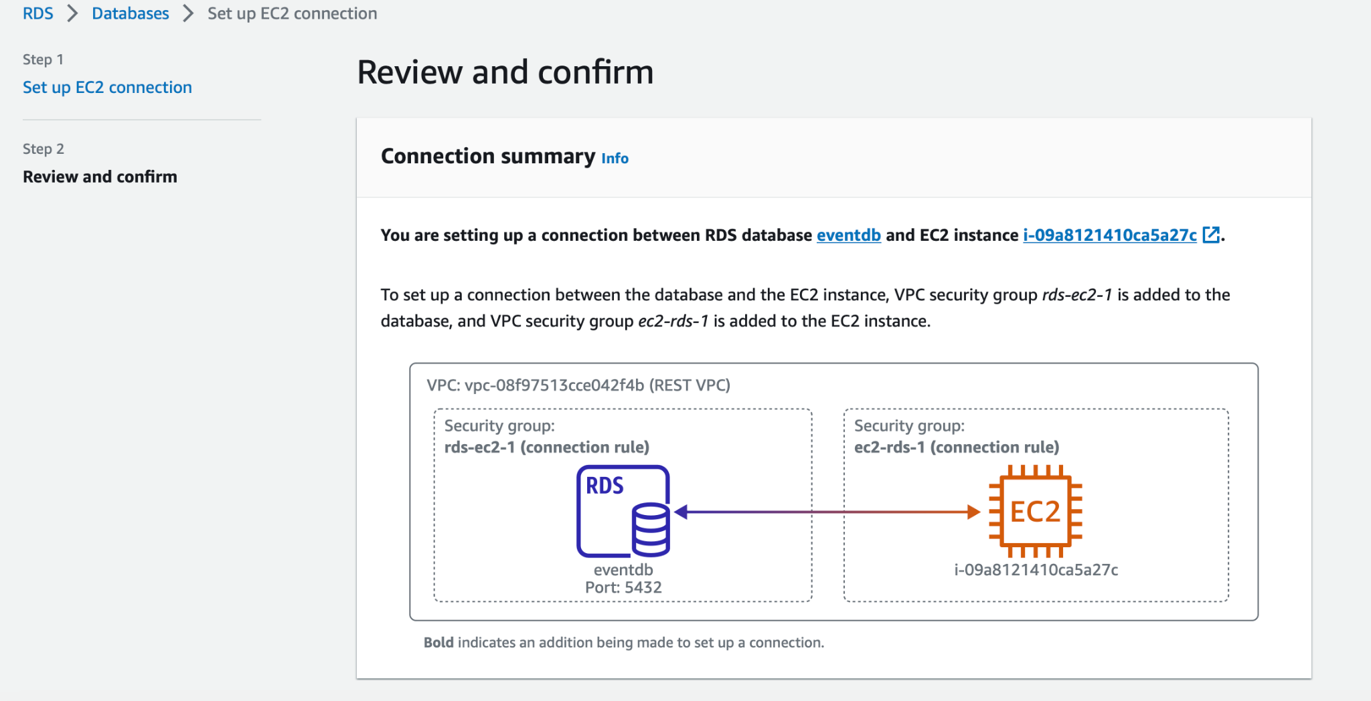
  + *Created db has endpoint, which we will use to connect from ec2 instance*
  + 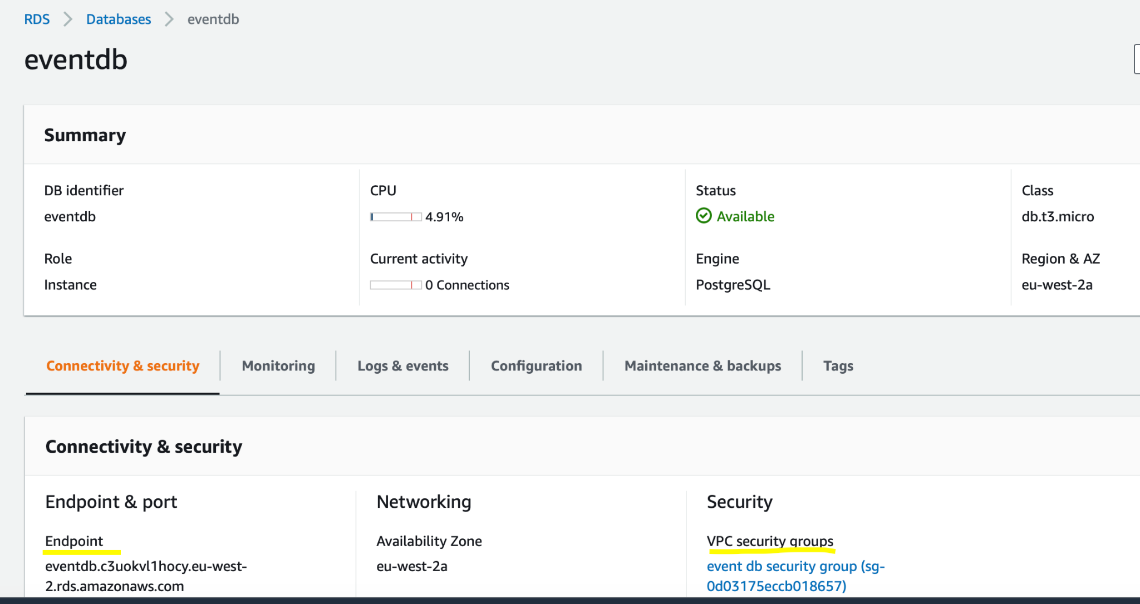
* *Create Busket(enable access)*
* *Add database credentials and endpoint to the application properties.file , instead of local*
* 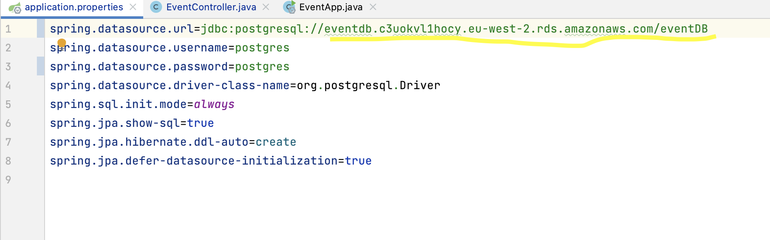
* *Package the app to jar and upload it into the s3 bucket*
* 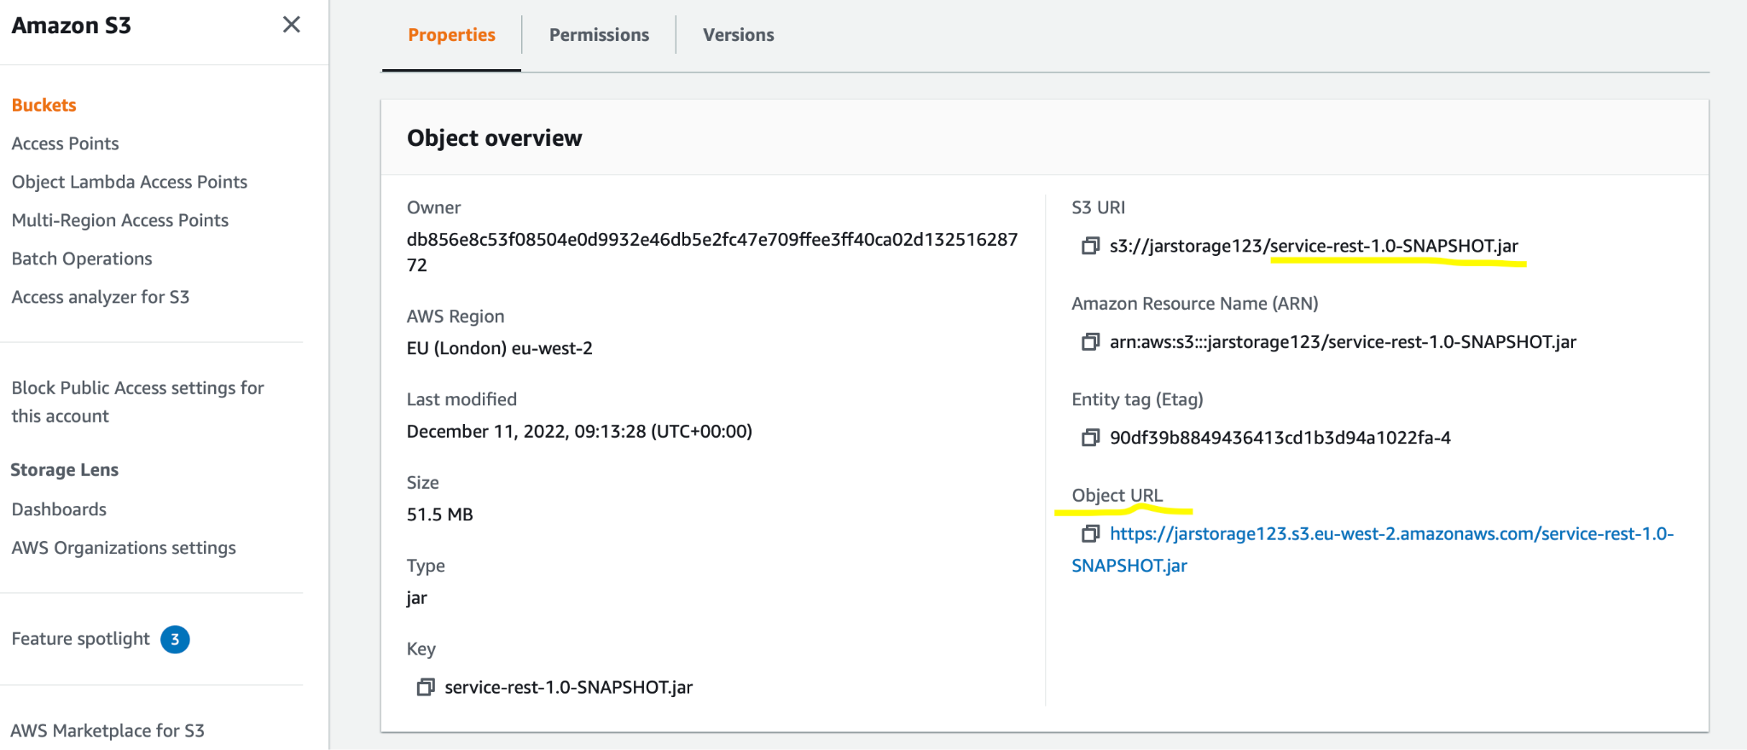
* Copy url from s3 bucket
* Connect to ec2 instance and get the jar from the s3

wget url

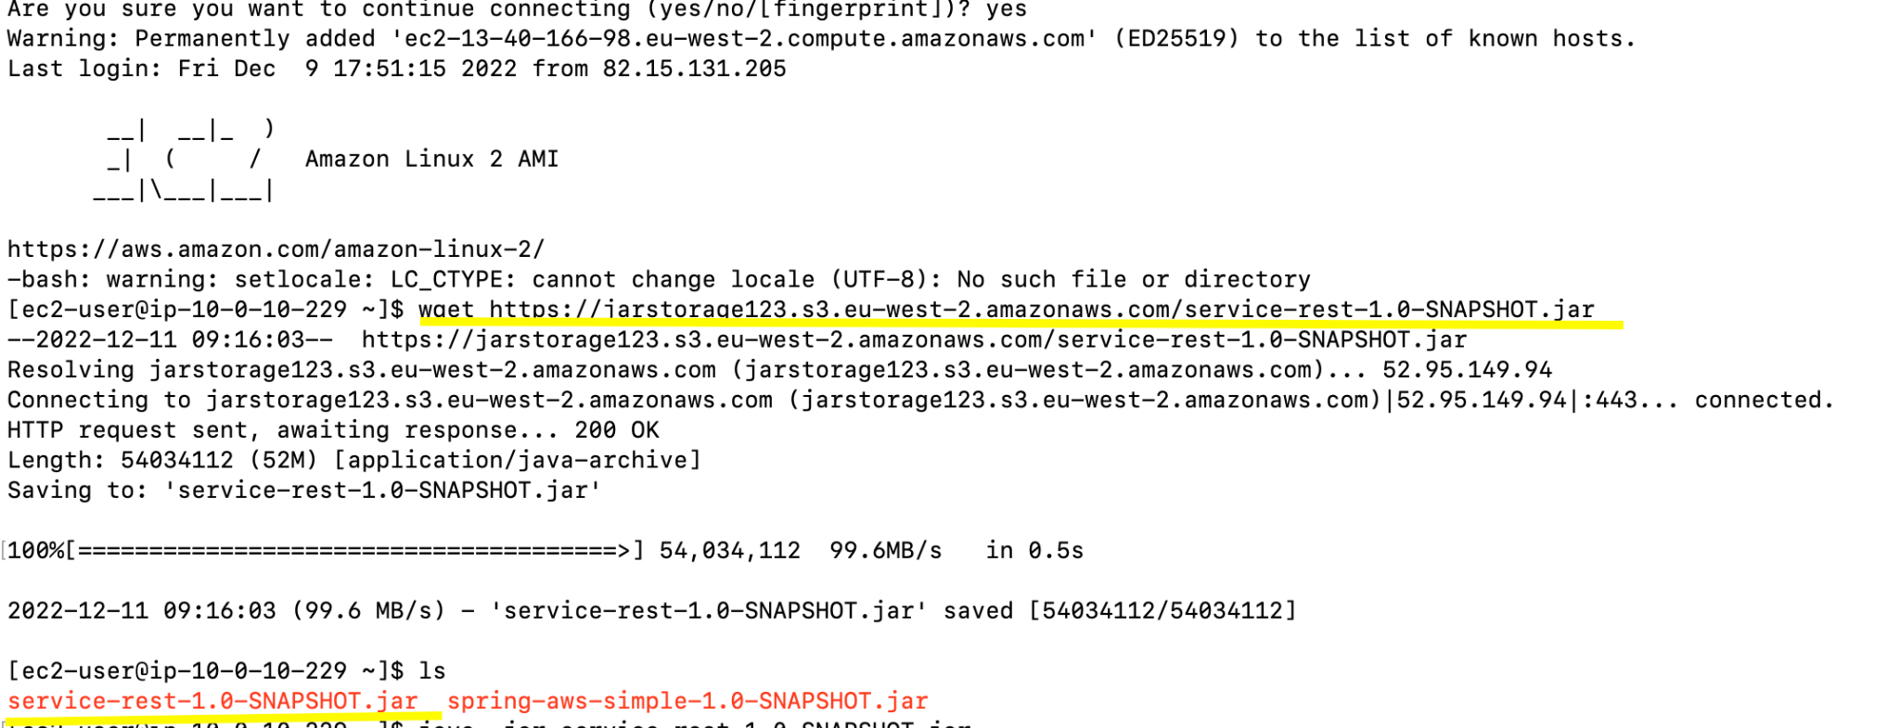

* Run application
* 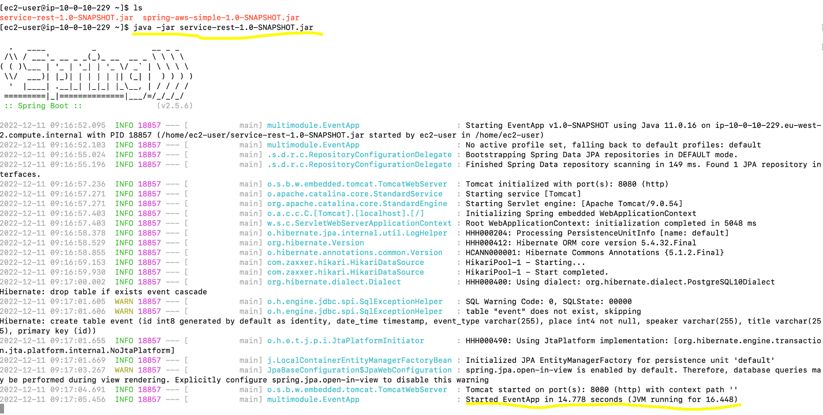
* Send request to te ec2 server using postman, to do this we need use DNS
* 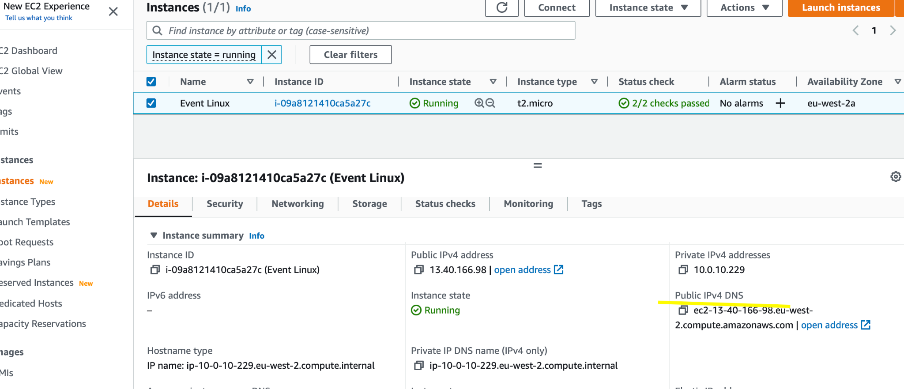
* Test request to the application
* 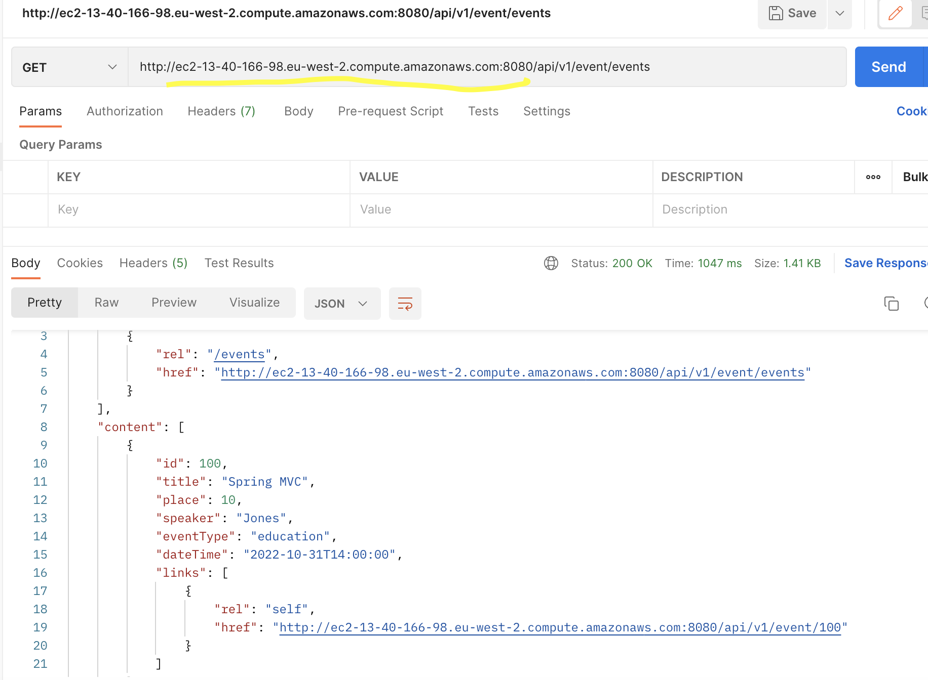

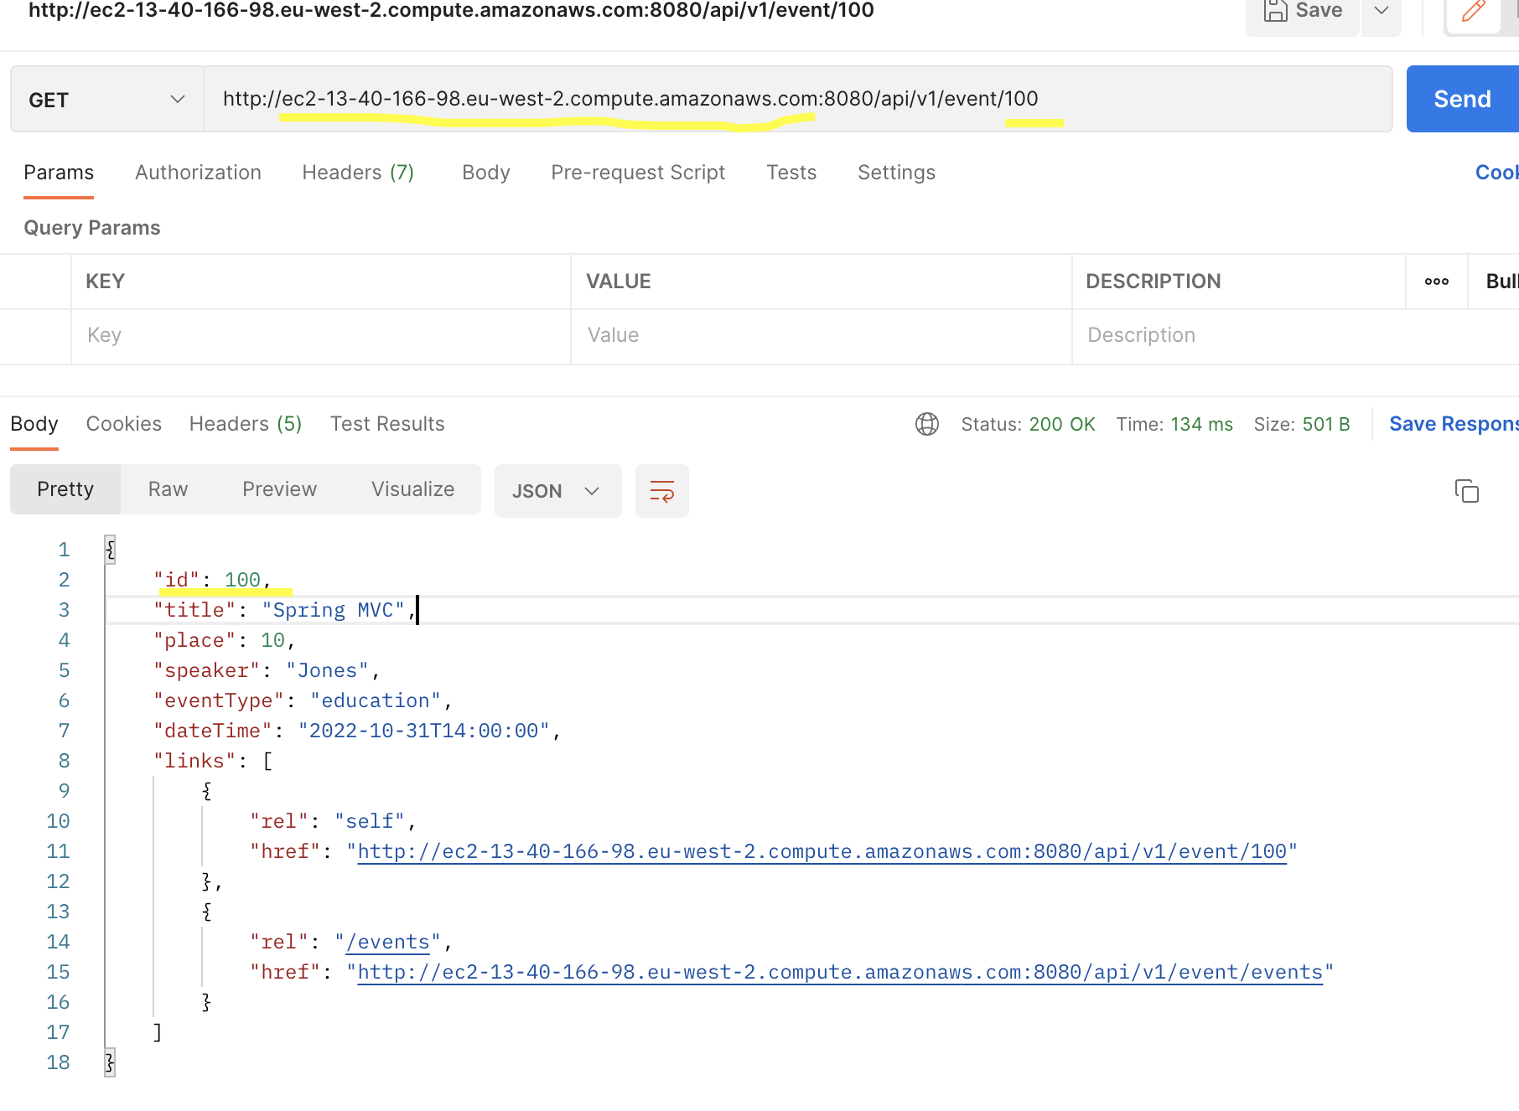

## Source

[AWS - Виртуальные Сети VPC - Часть-3 - Bastion Host и проверка Сети](https://www.youtube.com/watch?v=vTER05sRObI&list=PLg5SS_4L6LYsxrZ_4xE_U95AtGsIB96k9&index=30)

[Create and connect PostgreSQL by using AWS RDS and integrate with spring boot application in AWS EC2](https://www.youtube.com/watch?v=4T6O0XFBNXA)

[https://aws.amazon.com/getting-started/hands-on/?getting-started-all.sort-by=item.additionalFields.content-latest-publish-date&getting-started-all.sort-order=desc&awsf.getting-started-category=*all&awsf.getting-started-level=*all&awsf.getting-started-content-type=*all](https://aws.amazon.com/getting-started/hands-on/?getting-started-all.sort-by=item.additionalFields.content-latest-publish-date&getting-started-all.sort-order=desc&awsf.getting-started-category=*all&awsf.getting-started-level=*all&awsf.getting-started-content-type=*all)

<https://docs.aws.amazon.com/IAM/latest/UserGuide/introduction.html?icmpid=docs_iam_console>

<https://docs.aws.amazon.com/vpc/latest/userguide/what-is-amazon-vpc.html>

<https://docs.aws.amazon.com/AWSEC2/latest/UserGuide/concepts.html>

<https://docs.aws.amazon.com/AmazonRDS/latest/UserGuide/Welcome.html>

<https://aws.amazon.com/getting-started/hands-on/create-connect-postgresql-db/>